NAME:B.Tejaswini
REGNO.:192412684
ECA1803 OPTOELECTRONICS AND OPTICAL COMMUNICATION
CO3 SCENARIO-BASED ASSESSMENT
Design and Performance Evaluation of an Integrated Photodetection, Imaging, Biomedical Sensing and Display System
Executive Summary
This report proposes an integrated optoelectronic platform for wearable biomedical sensing, automotive LiDAR, imaging, UV sensing, face recognition, auxiliary photovoltaic power and advanced displays. Using the assignment data, the PPG photocurrent variation is 15 µA, the LiDAR photocurrent is 2.4 µA, the low-light power SNR is 15 dB (signal-to-noise power ratio 31.6:1), the approximate transit-time bandwidth is 22 GHz, and the PV maximum power estimated from Voc, Isc and fill factor is 2.25 W. PIN photodiodes are recommended for low-noise linear PPG and imaging; APDs are a strong candidate for low-return LiDAR where avalanche gain justifies added noise and bias complexity.
The final architecture uses a low-noise PIN detector for PPG, an APD receiver for LiDAR after verifying bandwidth and excess noise, CMOS imaging for face recognition and automotive cameras, a wavelength-appropriate UV photodiode, flexible PV for auxiliary wearable energy harvesting, and MicroLED for high-brightness compact AR/VR/MR where cost and packaging permit. OLED remains attractive for foldable displays. Numerical NEP, detectivity and quantum efficiency cannot be uniquely calculated from the provided data because wavelength, detector area and noise spectral density are not specified; the report gives the governing equations and required measurement inputs.

Given data and assumptions
Parameter | Given value / assumption
PPG responsivity | 0.60 A/W
PPG optical-power variation | 25 µW
LiDAR received optical power | 3 µW
LiDAR responsivity | 0.80 A/W
Low-light signal power | −22 dBm
Low-light noise power | −37 dBm
Detector transit time | 20 ps
Transit-time bandwidth relation | f ≈ 0.44/tr
PV open-circuit voltage | 0.60 V
PV short-circuit current | 5 A
PV fill factor | 0.75
Noise simulation assumptions only | B = 1 MHz, dark current = 10 nA, equivalent electronics noise = 5 pA RMS

The noise-model assumptions are illustrative because the assignment does not specify bandwidth, dark current or receiver electronics noise. They are explicitly labelled and are not treated as measured device specifications.

Stage 1 – Interpret the Application Requirements

1.1 Application requirements
- Wearable PPG: detect small reflected-light changes with high responsivity, low dark current, low input-referred noise, stable contact/optical coupling and low power consumption. Signal conditioning must reject ambient-light interference and motion artefacts.
- NIR spectroscopy: choose illumination and detector responsivity within the wavelength band of interest; use optical filters, calibrated source intensity and signal processing to estimate absorption or reflectance.
- Automotive LiDAR: combine high sensitivity with fast timing, suitable bandwidth, low noise, high dynamic range and reliable operation over temperature. Detector and readout bandwidth jointly determine timing precision.
- Weak-signal detection: NEP should be low, detectivity high, and noise bandwidth as narrow as compatible with the required signal dynamics. Optical filtering and good coupling improve signal-to-background ratio.
- Imaging and face recognition: require adequate spatial resolution, quantum efficiency, low read noise, dynamic range, frame rate, small pixel pitch and efficient sensor-to-SoC integration.
- UV sensing: use a detector whose spectral responsivity matches the UV band, with visible/IR rejection where required and suitable packaging to prevent unwanted optical leakage.
- PV and displays: flexible PV can supply auxiliary energy but output depends on illumination and area. Display selection balances brightness, contrast, efficiency, lifetime, heat, cost and mechanical flexibility.
- System integration: power, thermal design, optical alignment, calibration, reliability, privacy, eye safety for emitters and manufacturability must be considered.

1.2 Key detector metrics
Metric | Meaning / design implication
Responsivity R (A/W) | Photocurrent per incident optical power: Iph = RP.
Quantum efficiency η | Fraction of incident photons converted into collected carriers; wavelength-dependent.
NEP (W/√Hz) | Optical power giving signal equal to noise in a 1 Hz bandwidth; lower is better.
Detectivity D* | Area-normalized sensitivity, commonly D* = √A/NEP; higher is better.
Linearity | Ability to keep output proportional to input without saturation; important for imaging and accurate intensity measurement.
Bandwidth | Frequency range over which the detector/receiver follows the signal; limited by carrier transit and RC time constants.
Dark current | Current without incident light; contributes shot noise and can become important at low optical powers.

Application Requirement Statement: The platform must detect small biomedical optical variations and weak LiDAR returns with suitable sensitivity, noise and speed; provide accurate CMOS imaging and UV detection; support auxiliary PV power and an appropriate compact display; and integrate signal conditioning, processing and calibration within acceptable power, thermal, reliability and cost limits.

Stage 2 – Investigate and Select the Photodetector Configuration (20 marks)

2.1 PPG photocurrent variation
The parameter converting optical power to photocurrent is responsivity R, with ΔIph = RΔP.
Given R = 0.60 A/W and ΔP = 25 µW = 25 × 10⁻⁶ W:
ΔIph = 0.60 × 25 × 10⁻⁶ = 15 × 10⁻⁶ A = 15 µA.
PPG measures changes in transmitted or reflected light caused by pulsatile changes in blood volume. The pulsatile AC component is superimposed on a larger DC component from tissue, venous blood and non-pulsatile absorption. After filtering and processing, pulse rate and pulse-related features can be estimated; absolute physiological measurements require calibration and artefact rejection.

2.2 LiDAR photocurrent
Iph = RP = 0.80 A/W × 3 µW = 0.80 × 3 × 10⁻⁶ A = 2.4 µA.
This is the ideal photocurrent before considering multiplication gain, coupling losses, background light, dark current and circuit effects.

2.3 PIN versus APD comparison
Feature | PIN photodiode | Avalanche photodiode (APD)
Internal gain | Approximately unity | Internal avalanche multiplication M > 1
Sensitivity | Good when receiver electronics are low-noise | Can improve weak-signal sensitivity when receiver noise dominates
Noise | No avalanche excess-noise factor; dark-current shot noise remains | Multiplication increases signal and also avalanche excess noise
Bandwidth | Often high; device and RC dependent | Can be high but gain-bandwidth trade-off applies
Bias | Lower reverse bias | Higher bias near breakdown; requires careful control
Linearity | Generally good over specified range | Gain and linearity depend on bias, temperature and optical level
Complexity/power | Simpler, usually lower power | More complex bias, temperature compensation and protection
Best fit here | PPG and CMOS-style intensity sensing | LiDAR if weak-return sensitivity warrants the added noise and bias complexity

2.4 Dark current, quantum efficiency, NEP and detectivity
Dark current flows without illumination and creates shot noise with RMS current i_n = √(2qIdB) for a simple PIN model over equivalent noise bandwidth B. It lowers the minimum detectable signal, especially when the optical signal is weak. APDs add multiplication of dark-current components and avalanche excess noise.
Quantum efficiency is η = (number of collected electron-hole pairs)/(incident photons). Responsivity and quantum efficiency are related by R = ηqλ/(hc), or η = Rhc/(qλ). In convenient units, η ≈ R × 1240/λ_nm. Since the operating wavelength is not provided for each detector, a unique numerical quantum efficiency cannot be calculated.
Noise-equivalent power is NEP = in/R for input-referred current-noise spectral density in A/√Hz and responsivity R in A/W, yielding W/√Hz. Specific detectivity is D* = √A/NEP, where A is detector area. The assignment provides neither noise spectral density nor detector area, so numerical NEP and D* cannot be responsibly calculated without additional datasheet or measured data.
Linearity is important because saturation or gain compression distorts PPG amplitude, LiDAR return strength and image brightness. The detector should be operated within its specified linear range, and APD gain should be reduced if strong returns or background light risk saturation.

Design Decision 1 – Detector configuration
I recommend a low-noise PIN photodiode for PPG and general imaging intensity measurement, an APD for the LiDAR receiver when measured receiver-noise conditions justify avalanche gain, and dedicated wavelength-matched photodiodes for NIR and UV sensing. The calculated PPG variation is 15 µA and LiDAR photocurrent is 2.4 µA before gain. APD selection must be verified against excess noise, gain-bandwidth, dark current and high-voltage bias requirements.

Stage 3 – Noise and SNR Strategy

3.1 Low-light SNR calculation
For signal power Ps = −22 dBm and noise power Pn = −37 dBm, the power SNR in decibels is SNRdB = Ps(dBm) − Pn(dBm).
SNRdB = (−22) − (−37) = 15 dB.
Linear power ratio = 10^(15/10) = 31.62. Thus the stated signal power is about 31.6 times the stated noise power. This calculation assumes both values refer to comparable measurement bandwidths and power definitions.

3.2 Noise mechanisms
- Shot noise: statistical fluctuation in discrete charge carriers; for a PIN detector, i_shot,rms = √[2q(Id + Iph)B] under a simplified model.
- Dark-current noise: dark current contributes shot noise even in darkness. Reducing dark current and, where suitable, cooling the detector can improve weak-signal performance.
- Avalanche noise: APD multiplication is stochastic and introduces an excess-noise factor F(M). A simplified APD shot-noise relation is proportional to 2qM²F(M)(Iprimary)B.
- Thermal/electronics noise: receiver resistance and amplifier circuitry add noise; it can dominate when optical power is very low.
- Ambient-light noise: background photons add photocurrent and shot noise. Optical bandpass filters, shielding and synchronous/modulated detection can reduce its impact.
If received optical power decreases while dark current remains constant, the signal photocurrent decreases but dark-current noise does not decrease correspondingly. Therefore SNR falls. Increasing bandwidth also increases integrated white noise approximately proportional to √B in RMS current, so bandwidth should be no larger than the application requires.

3.3 Recommended SNR improvements
- Use APD gain only when it improves the receiver noise budget; do not maximize multiplication blindly because avalanche excess noise and bandwidth loss can offset the gain.
- Use optical filters matched to the LED/laser wavelength and reject ambient light.
- Choose a low-dark-current detector and consider cooling only where power, size and condensation constraints permit.
- Optimize bandwidth to the useful signal; use low-noise transimpedance amplification and appropriate filtering.
- Improve optical coupling and alignment, while avoiding saturation and excess ambient-light collection.
- For PPG, combine ambient-light subtraction, AC/DC separation, averaging and motion-artifact rejection.

Design Decision 2 – Noise/SNR configuration
I recommend a low-noise front end with wavelength-selective optical filtering, optimized bandwidth, good coupling and application-appropriate detector gain. The supplied low-light powers give 15 dB SNR. Use a PIN detector where receiver electronics noise is already low; use an APD only when its multiplication improves total receiver sensitivity after accounting for avalanche noise and bias complexity.

Stage 4 – Response Time, Bandwidth and High-Speed Detection

4.1 Transit-time bandwidth
Given transit time tr = 20 ps = 20 × 10⁻¹² s and f ≈ 0.44/tr:
f ≈ 0.44/(20 × 10⁻¹²) = 22 × 10⁹ Hz = 22 GHz.
This is the approximate transit-time-limited bandwidth only. The total bandwidth may be lower because of the RC time constant, package parasitics, TIA bandwidth and any avalanche gain-bandwidth trade-off.

4.2 Transit time and RC limitation
- Carrier transit time: carriers require finite time to cross the depletion/absorption region. A thinner region or stronger electric field may reduce transit time, but absorption efficiency and breakdown constraints also matter.
- RC time constant: detector capacitance and load/input resistance create a low-pass limit, approximately fRC = 1/(2πRtotalCtotal).
- Active-area trade-off: larger area captures more light and eases alignment but increases capacitance and can reduce bandwidth. Smaller area improves speed but can reduce coupling tolerance and collected signal.
- Receiver electronics: the photodiode, package, interconnect and transimpedance amplifier must be co-designed; the overall bandwidth is limited by the slowest significant stage.

Design Decision 3 – High-speed detector
I recommend a small-area, low-capacitance PIN detector for high-speed imaging/receiver paths and an APD for LiDAR only if the complete APD-plus-TIA assembly achieves the required timing bandwidth. The transit-time estimate is 22 GHz, but it is not a guarantee of 22 GHz system bandwidth; RC and receiver-circuit measurements are required.

Stage 5 – PV, Image Sensors and Emerging Displays

5A. Solar photovoltaic analysis
The maximum power estimate from open-circuit voltage, short-circuit current and fill factor is Pmax = Voc × Isc × FF.
Pmax = 0.60 V × 5 A × 0.75 = 2.25 W.
Voc is the terminal voltage at zero current; Isc is the current at zero terminal voltage. Fill factor FF = Pmax/(VocIsc) describes how rectangular the I–V curve is and captures internal resistive/recombination losses. PV conversion efficiency requires incident optical power: ηPV = Pmax/Pin. Because irradiance and cell area are not supplied, efficiency cannot be calculated.
Flexible PV can conform to a wearable surface and supply auxiliary energy, but typically faces trade-offs in conversion efficiency, durability under bending, encapsulation, area, illumination dependence and long-term reliability. It should be treated as auxiliary harvesting rather than a guaranteed sole power source.

5B. CMOS versus CCD image sensors
Aspect | CMOS | CCD
Readout | Pixel/column circuitry converts and reads charge locally | Charge packets are shifted across the chip to output amplifiers
Power | Usually lower, with integrated electronics | Often higher due to clocking and readout architecture
Speed | Fast readout and high frame-rate options | Can offer excellent uniformity but readout may be slower
Noise | Modern CMOS can achieve low read noise; varies by architecture | Historically strong uniformity/low noise, depending on device
Integration | Well suited to ADC, timing and processing SoC integration | Less straightforward monolithic system integration
Pixel scaling | Highly scalable; small pixels trade full-well capacity and photon collection | Pixel design also faces area and charge-transfer constraints
Application | Preferred for face recognition, automotive cameras and compact systems | Useful where specialized image quality and established CCD characteristics are required

As pixel dimensions shrink, resolution per area can rise, but each pixel generally collects fewer photons and may have reduced full-well capacity and signal-to-noise ratio in low light. Microlenses, back-side illumination, stacked sensors and computational processing can mitigate some trade-offs. Small pixels also make sensor/SoC integration attractive.

5C. OLED, MicroLED and quantum-dot displays
Technology | Strengths | Limitations | Best-fit use
OLED | Self-emissive pixels, deep blacks, high contrast, fast response and flexible form factors | Burn-in/aging risk, brightness/lifetime trade-offs and material sensitivity | Foldable phones and compact high-contrast displays
MicroLED | Very high brightness potential, fast response, high contrast and long lifetime potential | Mass-transfer/manufacturing complexity, cost and repair challenges | High-brightness AR/VR/MR and premium displays when manufacturing is mature
Quantum-dot display | Strong colour gamut and efficient colour conversion/emission depending on architecture | Performance depends on implementation; some designs require a separate backlight and material encapsulation | Wide-colour-gamut TVs/monitors and selected compact displays

For a foldable consumer device, OLED is the most practical choice because it supports flexible panels. For high-brightness AR/VR/MR, MicroLED is attractive if cost, yield and optical coupling requirements can be met. Quantum-dot displays are attractive where colour gamut and brightness are prioritized; the exact architecture must be specified before comparing efficiency.

Design Decision 4 – PV, image sensor and display
I recommend flexible PV as auxiliary wearable energy harvesting, CMOS image sensors for face recognition and automotive imaging, OLED for foldable consumer displays, and MicroLED as the preferred high-brightness AR/VR/MR option when manufacturing cost permits. The calculated PV maximum power is 2.25 W under the supplied Voc, Isc and FF data, but real output depends on illumination and load operating point.

Stage 6 – Biomedical and Industrial Applications

6.1 Wearable PPG
An LED illuminates tissue and a PIN photodiode measures reflected light. Pulsatile blood-volume changes modulate absorption/scattering and produce a small AC optical signal over a larger DC background. For the supplied values, a 25 µW optical variation produces 15 µA photocurrent variation. Use optical shielding, ambient-light subtraction, low-noise TIA, band-pass filtering and motion-artifact processing. Green light is often useful for wrist PPG; red/NIR may be selected for deeper penetration or specific measurement goals.

6.2 NIR spectroscopy
NIR spectroscopy illuminates biological material and measures transmitted or reflected intensity at selected wavelengths. Different constituents have wavelength-dependent absorption features. Use a suitable NIR source, detector with adequate responsivity, narrow optical filters, reference measurements and calibration. The detector must have sufficient dynamic range and low noise; interpretation requires application-specific calibration rather than assuming a unique biological concentration from one intensity value.

6.3 Automotive LiDAR
A pulsed or modulated optical source sends light toward a target. The receiver detects a weak return and estimates range from time of flight, d = cΔt/2 for a pulsed system. With 3 µW received power and 0.80 A/W responsivity, ideal photocurrent is 2.4 µA. An APD can improve sensitivity when receiver electronics noise is limiting, but the complete detector/TIA bandwidth, timing jitter, sunlight rejection and eye safety must be validated.

6.4 Face recognition
A CMOS sensor provides image frames for feature extraction and matching. Visible-light face recognition uses an appropriate image sensor and illumination; NIR-assisted systems may use NIR LEDs and a sensor with suitable NIR response for low-light or controlled illumination. Resolution, pixel size, exposure, frame rate, dynamic range, illumination uniformity and privacy safeguards are important.

6.5 UV sensing
A UV sensor should have responsivity matched to the target UV band and reject visible/IR light when selective UV measurement is needed. Candidate technologies include silicon photodiodes with suitable UV response and filters, or wide-bandgap UV photodiodes for improved visible-blind operation. Packaging, calibration, temperature dependence and optical-window transmission must be considered.

Design Decision 5 – Application-specific configuration
I recommend PIN-based PPG with low-noise conditioning, an APD-based LiDAR receiver subject to bandwidth/noise qualification, CMOS visible/NIR imaging for face and automotive sensing, and a wavelength-matched UV photodiode with optical filtering. NIR spectroscopy should use calibrated source-detector pairs and wavelength-selective filtering.

Stage 7 – MATLAB/SCILAB Simulation and Verification
The plots below are illustrative numerical models generated from the stated responsivity relation and explicitly labelled assumptions. They are not measured device data. The MATLAB code at the end reproduces the model and calculates the key theoretical values.

7A. Responsivity model
For R = 0.60 A/W, Iph = RP. Therefore a 25 µW variation gives 15 µA, and the current-power relationship is linear until saturation.
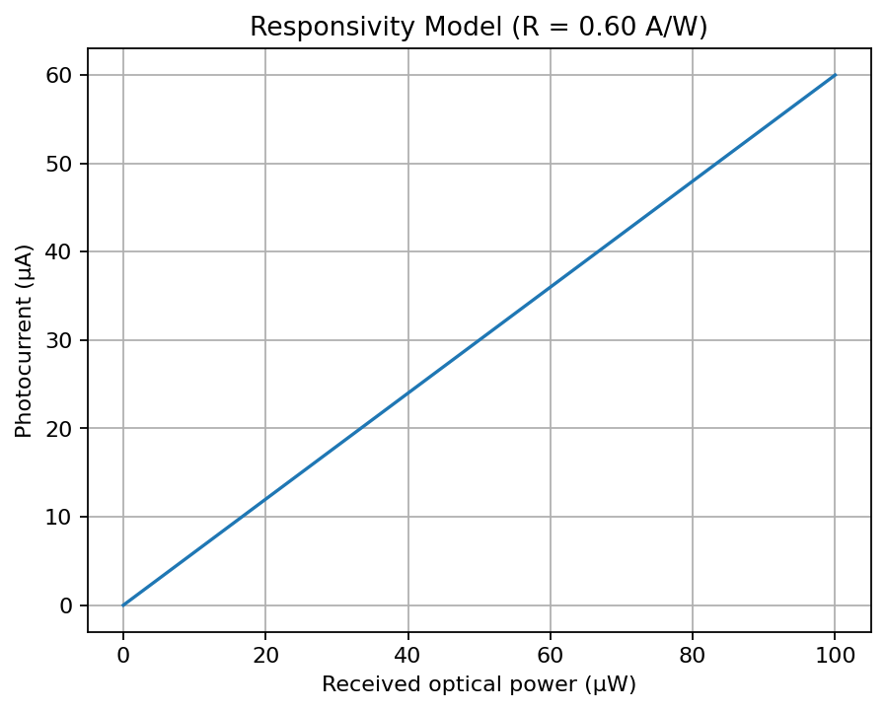

7B. Noise model
Illustration assumes B = 1 MHz and Id = 10 nA. The simple PIN shot-noise model is i_n = √[2q(RP + Id)B]. Actual total noise must also include electronics, background and (for APDs) avalanche excess noise.
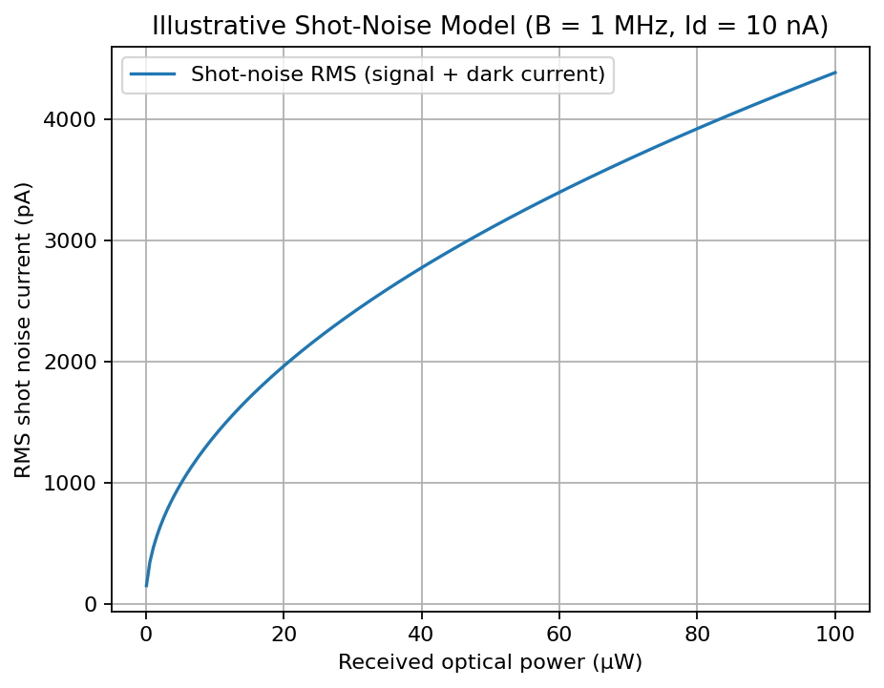

7C. Illustrative SNR model
For illustration only, the graph uses the same bandwidth and dark-current assumptions plus 5 pA RMS equivalent electronics noise. It plots current-domain signal-to-noise ratio as 20log10(Isignal/Inoise). This model is distinct from the assignment's given −22 dBm/−37 dBm power-SNR calculation.
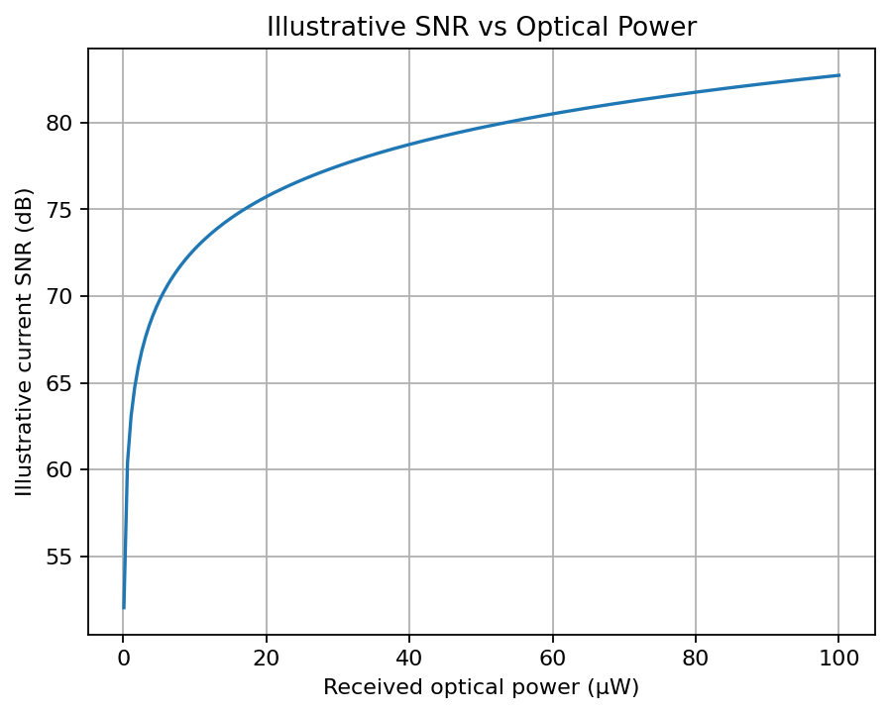

7D. MATLAB code
% ECA18 CO3 optoelectronic sensing model
clear; clc; close all;
q = 1.602176634e-19;
Rppg = 0.60; dP = 25e-6;
Plidar = 3e-6; Rlidar = 0.80;
tr = 20e-12;
Voc = 0.60; Isc = 5; FF = 0.75;

Ippg = Rppg*dP;
Ilidar = Rlidar*Plidar;
SNRdB = (-22)-(-37);
SNRlinear = 10^(SNRdB/10);
ftransit = 0.44/tr;
PmaxPV = Voc*Isc*FF;

fprintf('PPG photocurrent variation = %.2f uA\n', Ippg*1e6);
fprintf('LiDAR photocurrent = %.2f uA\n', Ilidar*1e6);
fprintf('Power SNR = %.2f dB (ratio %.2f)\n', SNRdB, SNRlinear);
fprintf('Transit-time bandwidth = %.2f GHz\n', ftransit/1e9);
fprintf('PV maximum power estimate = %.2f W\n', PmaxPV);

% Responsivity model
P = linspace(0,100e-6,201);
I = Rppg*P;
figure; plot(P*1e6,I*1e6,'LineWidth',1.5); grid on;
xlabel('Optical power (uW)'); ylabel('Photocurrent (uA)');
title('Responsivity model: R = 0.60 A/W');

% Illustrative noise and SNR model; assumptions, not supplied measurements
B = 1e6; Id = 10e-9; iElectronics = 5e-12;
P2 = linspace(0.1e-6,100e-6,200);
I2 = Rppg*P2;
iShot = sqrt(2*q*(I2+Id)*B);
figure; plot(P2*1e6,iShot*1e12,'LineWidth',1.5); grid on;
xlabel('Optical power (uW)'); ylabel('RMS shot noise (pA)');
title('Illustrative shot-noise model, B=1 MHz, Id=10 nA');

iTotal = sqrt(iShot.^2 + iElectronics^2);
SNRcurrentdB = 20*log10(I2./iTotal);
figure; plot(P2*1e6,SNRcurrentdB,'LineWidth',1.5); grid on;
xlabel('Optical power (uW)'); ylabel('Current SNR (dB)');
title('Illustrative SNR model with 5 pA RMS electronics noise');

7E. Theoretical results and interpretation
Quantity | Theoretical result | Interpretation
PPG photocurrent variation | 15 µA | Directly follows I = RP
LiDAR photocurrent | 2.4 µA | Before APD gain and losses
Given low-light power SNR | 15 dB; ratio 31.62 | Assumes signal/noise power measured in same bandwidth
Transit-time bandwidth | 22 GHz | Actual system bandwidth may be lower due to RC/TIA limits
PV maximum power estimate | 2.25 W | Efficiency unavailable without incident optical power
NEP / detectivity | Not numerically determinable | Need noise spectral density and detector active area
Quantum efficiency | Not numerically determinable | Need operating wavelength for each detector

Final System Verification
Requirement | Target / calculated | Assessment
PPG photocurrent response | 15 µA variation | Satisfactory by direct calculation; real optical coupling and noise must be measured
LiDAR photocurrent | 2.4 µA before gain | Satisfactory ideal calculation; receiver sensitivity/timing still require validation
Responsivity | 0.60 A/W PPG; 0.80 A/W LiDAR | Given values used consistently
Quantum efficiency | η = Rhc/(qλ) | Cannot numerically verify without wavelength
NEP / detectivity | NEP = in/R; D* = √A/NEP | Cannot numerically verify without noise density and area
Low-light SNR | 15 dB | Satisfactory arithmetic; ensure equal measurement bandwidth
Noise performance | PIN/APD noise model and filtering | Illustrative model only; replace assumptions with datasheet/measurements
High-speed bandwidth | 22 GHz transit estimate | Potentially fast; RC and receiver bandwidth need test
PV maximum power | 2.25 W | Calculated from given Voc, Isc and FF; operating conditions unspecified
Image sensor | CMOS | Recommended for integration, speed and power
Display | OLED foldable; MicroLED AR/VR/MR | Application-dependent selection
Biomedical sensing | PIN PPG + calibrated NIR spectroscopy | Plausible; needs validation and calibration
LiDAR/automotive | APD + high-speed TIA and CMOS camera | Plausible; eye safety, sunlight and timing tests needed
Face recognition / UV | CMOS image sensor; UV-specific photodiode | Wavelength and performance qualification required
MATLAB/SCILAB | Code and three model plots included | Reproducible model; simulation assumptions clearly stated
Overall platform | Integrated heterogeneous sensing platform | Prototype recommendation; not deployment-ready before validation

Final Integrated System Block Diagram
Wearable path: LED (green/red/NIR) → tissue → PIN photodiode → low-noise TIA → filters/ADC → PPG/NIR processing ┐
LiDAR path: pulsed laser → scene/target → APD → high-speed TIA/TDC → range/point-cloud processing
Imaging path: lens/IR filter → CMOS image sensor → ISP/SoC → face recognition / automotive perception
UV path: UV optics/filter → UV photodiode → amplifier/ADC → UV estimate
Energy path: flexible PV → power management / battery charging
Display path: application processor → display driver → OLED foldable panel / MicroLED AR-VR display
↓
Integrated SoC, calibration, power/thermal management and data interface

Final Parameter / Design Table
Subsystem | Recommended configuration | Key value / rationale
PPG | Green/red LED + PIN photodiode + low-noise TIA | ΔI = 15 µA for ΔP = 25 µW
NIR spectroscopy | Calibrated NIR source + filtered PIN/InGaAs detector selected by wavelength | Use wavelength-specific responsivity and calibration
LiDAR | APD + high-speed TIA/TDC | Iph = 2.4 µA before multiplication; transit estimate 22 GHz
Image/face/automotive | CMOS sensor with ISP/SoC integration | Good power, speed and integration trade-off
UV | UV-specific photodiode and optical filter | Choose spectral response for target UV band
PV | Flexible PV for auxiliary harvesting | Pmax estimate = 2.25 W under given parameters
Foldable display | OLED | Flexible form factor and high contrast
AR/VR/MR display | MicroLED where cost/yield allow | High brightness and fast response potential
Noise strategy | Optical filtering, low-dark-current detector, optimized bandwidth, low-noise TIA | SNR given = 15 dB; noise inputs need measurement
Simulation | MATLAB/SCILAB responsivity, noise and SNR models | Assumptions documented; code supplied

Final Engineering Decision – Would You Deploy It?
NO, not directly as a production system. YES, as a prototype design for laboratory verification. The theoretical calculations support the core responsivity, SNR, bandwidth and PV estimates. However, deployment should wait for detector-specific quantum efficiency, measured NEP/detectivity, real noise spectra, APD gain and excess-noise characterization, complete receiver bandwidth, PV output under realistic illumination, image quality, display thermal/power validation, UV calibration, end-to-end application tests and reliability assessment.

Conclusion
The proposed platform uses application-specific detection rather than one detector technology for every task. PIN photodiodes provide a simple low-noise choice for PPG and many imaging measurements; APDs can improve weak-return LiDAR sensitivity if their excess noise and bandwidth are acceptable. CMOS is preferred for compact integrated imaging, flexible PV supports auxiliary energy harvesting, OLED suits foldable devices and MicroLED is promising for high-brightness near-eye displays. The key calculated results are 15 µA PPG variation, 2.4 µA LiDAR photocurrent, 15 dB low-light SNR, 22 GHz transit-time bandwidth and 2.25 W PV maximum power estimate. NEP, detectivity and quantum efficiency require additional parameters and must not be guessed. MATLAB/SCILAB models provide a reproducible first verification step, but real measurements are necessary before deployment.

References / technical basis
- CO3 scenario-based assignment brief and its supplied parameters.
- Photodetector relations: Iph = RP; η = Rhc/(qλ); NEP = input-referred noise current spectral density / responsivity; D* = √A/NEP.
- Photodiode noise relations: PIN shot noise approximately √(2q(Iph + Id)B); APD noise includes avalanche multiplication and excess-noise factor.
- PV relation: Pmax = Voc × Isc × FF; conversion efficiency requires incident optical power.
Submission note: Add student details. Confirm course-specific reference editions and replace illustrative simulation assumptions with your instructor's required values if provided.

